**The Electric Motor**

A current-carrying coil pivoted in a uniform magnetic field will begin to rotate. That the coil will rotate only until it is at right angles to the field, and then it will stop. For the coil to continue to rotate, the direction of the force on it would have to change every half rotation. This could happen only by changing the direction of either the external magnetic field or the current flowing through the coil.

**Figure 5** shows how it is possible to switch the direction of the current every half rotation.

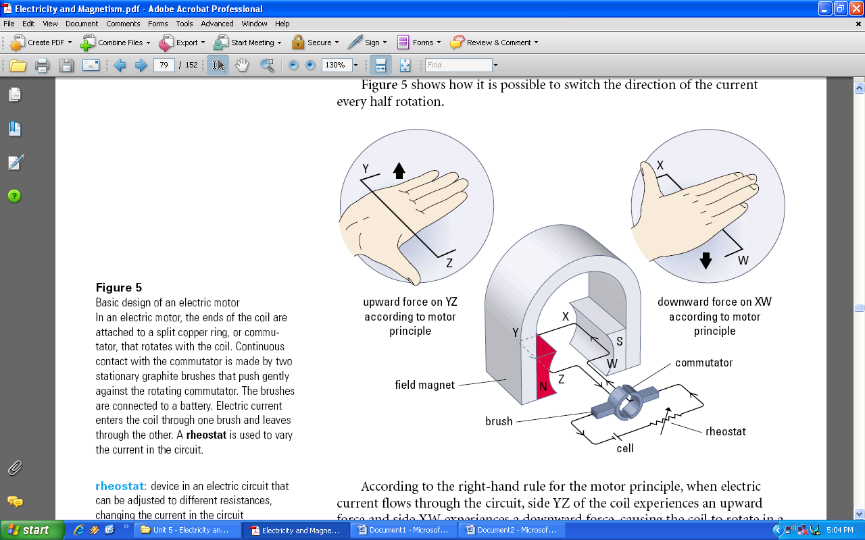

**Rheostat:** device in an electric circuit that can be adjusted to different resistances, changing the current in the circuit

According to the right-hand rule for the motor principle, when electric current flows through the circuit, side YZ of the coil experiences an upward force and side XW experiences a downward force, causing the coil to rotate in a clockwise direction, as illustrated. As the rotating coil reaches the vertical position, both brushes come opposite the gap between the commutator segments and no charge flows. However, the inertia of the coil keeps it rotating until the brushes make contact again, this time each with the other half of the ring. This causes the direction of the electric current through the coil to be reversed, so there is now a downward force on YZ, causing it to continue rotating in a clockwise direction. This switching procedure is repeated every half cycle as long as there is electric current in the brushes. Reversing the polarity of either the magnet or the battery will cause the coil to rotate in the opposite direction.

**Figure 6** shows the relative positions of the armature, coil, graphite brushes, and commutator at four positions during one cycle of a DC motor, with an iron armature and an external source connected.

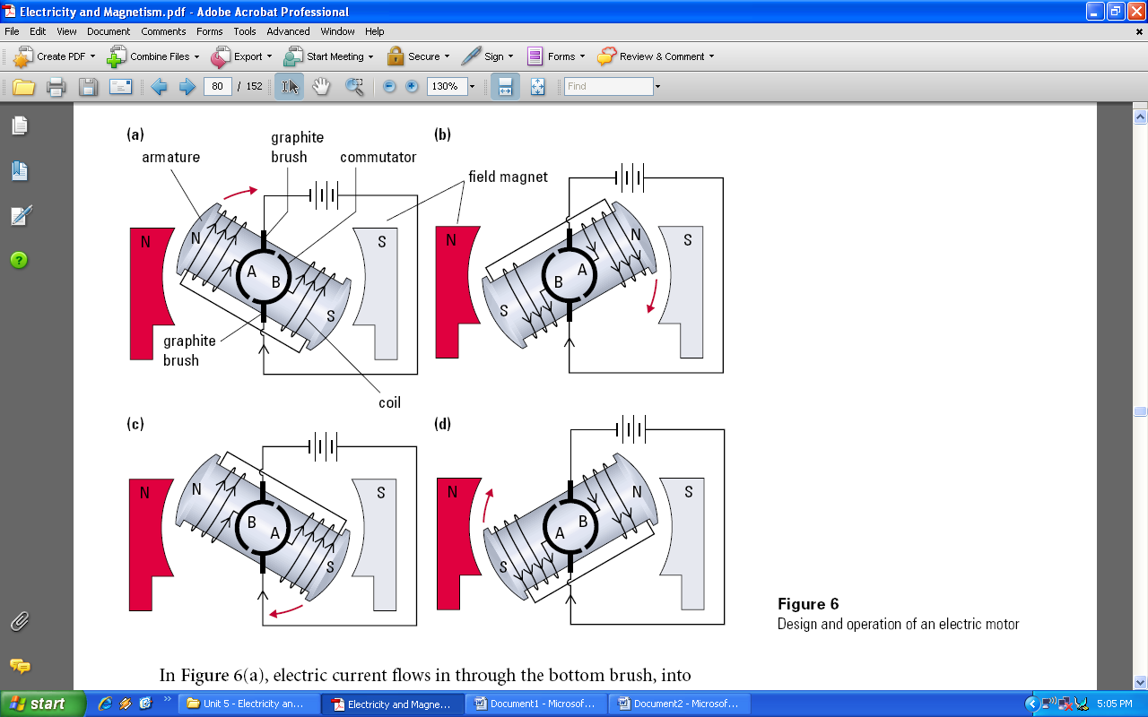

In **Figure 6(a)**, electric current flows in through the bottom brush, into commutator segment B, and through the coil, eventually entering commutator segment A and leaving the motor through the top brush. End A of the armature becomes an N-pole, using the right-hand rule, and is repelled by the N-pole of the field magnet, causing it to move away and rotate clockwise.

In **Figure 6(b)**, tracing the path of electric current through the motor verifies that end A remains an N-pole and is, therefore, attracted toward the S-pole of the field magnet.

In **Figure 6(c)**, a significant change occurs. The top brush is now in contact with commutator segment B. Electric current continues to flow up through the coils, leaving by commutator segment B and the top brush. End A of the armature now becomes an S-pole and is repelled by the S-pole of the field magnet, causing the clockwise motion to continue.

Again, tracing the flow of electric current through the motor in **Figure 6(d)** confirms that end A of the armature remains an S-pole and is attracted toward the N-pole of the field magnet, completing one full rotation of the motor.

This simple electric motor is not very powerful or efficient. To increase its power an armature is used. The high relative magnetic permeability of the iron core and the large number of windings increases the magnetic field strength of the armature. These factors combine to produce a large force on the coil, causing it to rotate rapidly. A strong electromagnet is often used as the field magnet.

Practical electric motors have more coils connected to a multi-segmented commutator. Each coil is connected to two oppositely located commutator segments that allow current to flow through when the coil is perpendicular to the magnetic field. This will help to maximize the force on the armature, making a more powerful motor that doesn’t require an initial push to get it going.

The rate of rotation of such a motor is easily controlled by varying the current in the coils using a rheostat. Small motors controlled in this way are often used in battery-operated toys. Subway trains, street cars, and diesel electric locomotives use large-scale motors based on these principles.

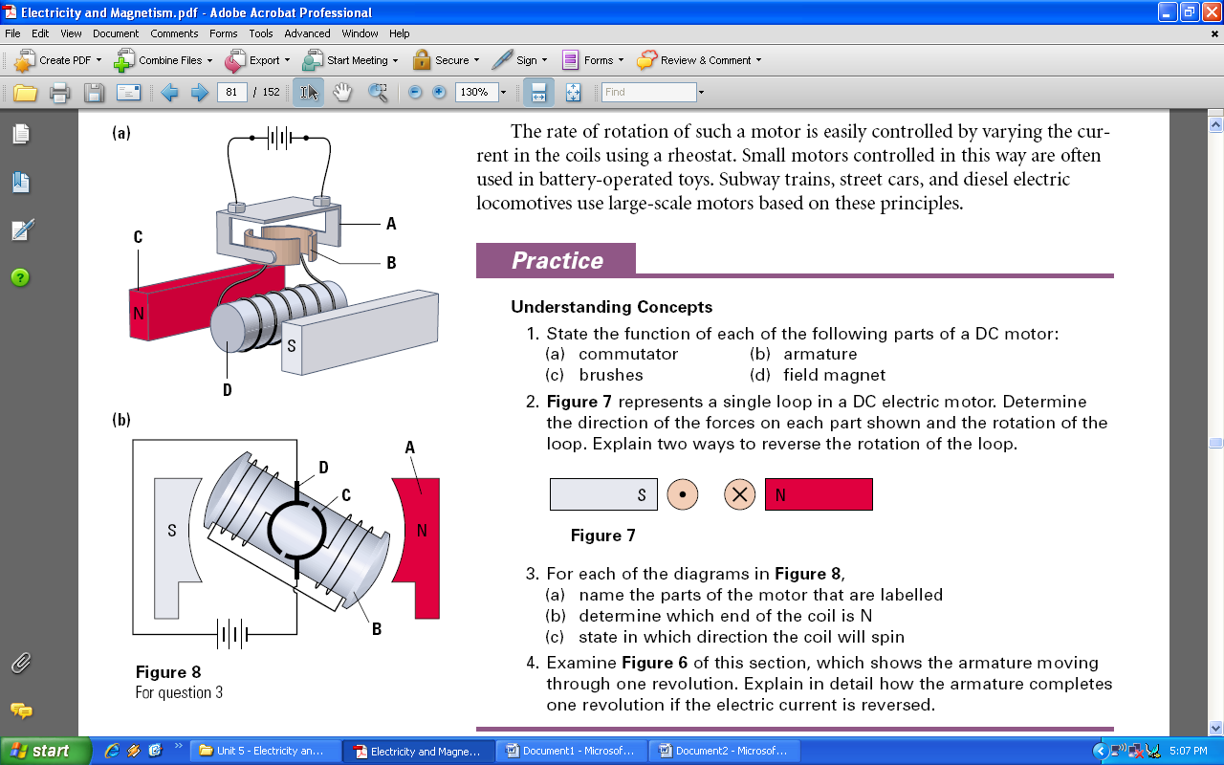

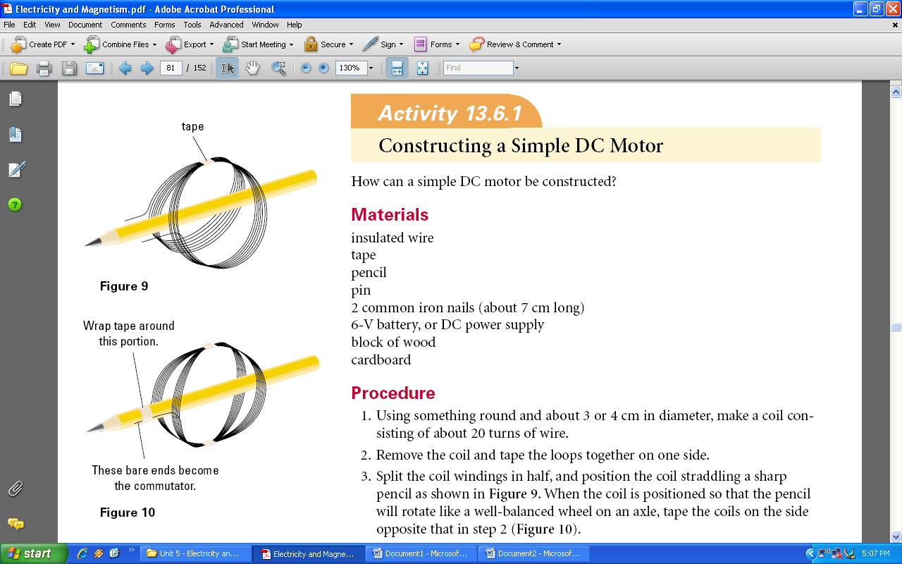

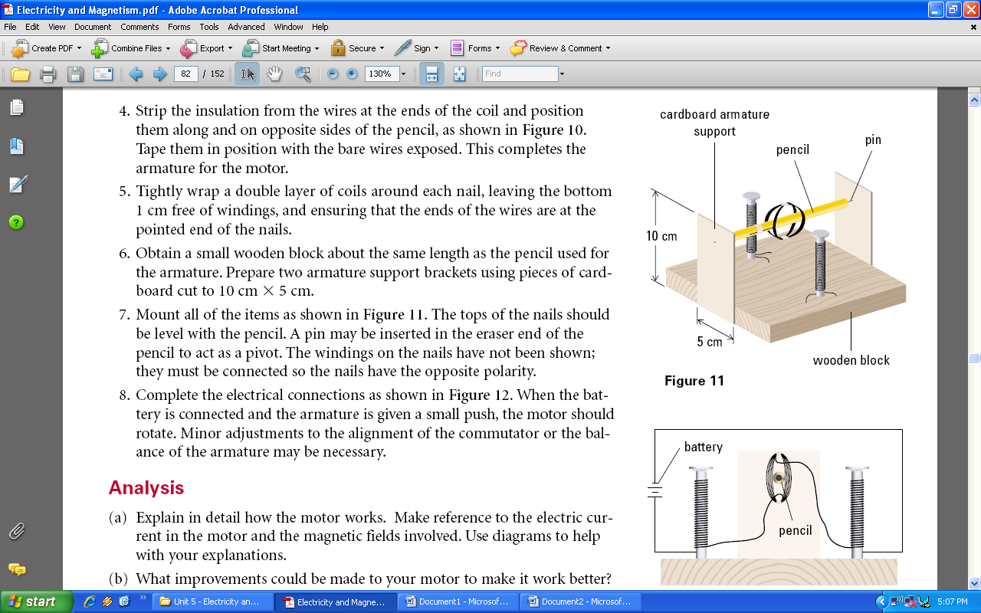

**Figure 12**

The motors described in this section are DC motors. However, AC motors are also commonly available. The construction and operation of an AC motor differs from that of a DC motor.

**Difference between DC & AC power?**

**DC Power:**

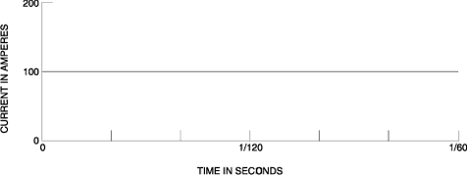

**AC Power:**

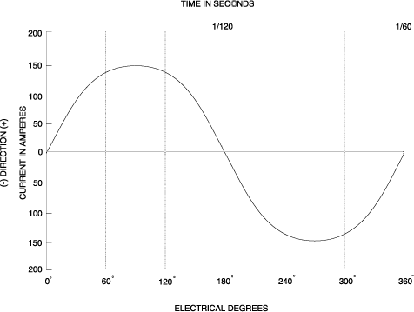

An AC motor has two basic electrical parts: a "stator" and a "rotor" as shown in **Figure 8**. The stator is in the stationary electrical component. It consists of a group of individual electro-magnets arranged in such a way that they form a hollow cylinder, with one pole of each magnet facing toward the center of the group.

The term, "stator" is derived from the word stationary. The stator then is the stationary part of the motor. The rotor is the rotating electrical component. It also consists of a group of electro-magnets arranged around a cylinder, with the poles facing toward the stator poles. The rotor, obviously, is located inside the stator and is mounted on the motor's shaft. The term "rotor" is derived from the word rotating. The rotor then is the rotating part of the motor. The objective of these motor components is to make the rotor rotate which in turn will rotate the motor shaft. This rotation will occur because of the previously discussed magnetic phenomenon that unlike magnetic poles attract each other and like poles repel. If we progressively change the polarity of the stator poles in such a way that their combined magnetic field rotates, then the rotor will follow and rotate with the magnetic field of the stator.

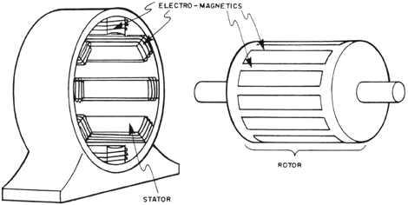

*Figure 8 - Basic electrical components of an AC motor.*

This "rotating magnetic fields of the stator” can be better understood by examining **Figure 9**. As shown, the stator has six magnetic poles and the rotor has two poles. At time 1, stator poles A-1 and C-2 are north poles and the opposite poles, A-2 and C-1, are south poles. The S-pole of the rotor is attracted by the two N-poles of the stator and the N-pole of the rotor is attracted by the two south poles of the stator. At time 2, the polarity of the stator poles is changed so that now C-2 and B-1 and N-poles and C-1 and B-2 are S-poles. The rotor then is forced to rotate 60 degrees to line up with the stator poles as shown. At time 3, B-1 and A-2 are N. At time 4, A-2 and C-1 are N. As each change is made, the poles of the rotor are attracted by the opposite poles on the stator. Thus, as the magnetic field of the stator rotates, the rotor is forced to rotate with it.

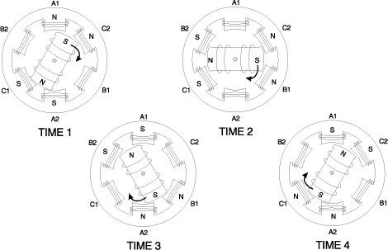

*Figure 9 - The rotating magnetic field of an AC motor.*